Complete Questions X to X using the answer sheet provided.
Please enter your Name and Student ID number on the answer sheet (Example below).
Enter the unit code next to Section. Eg. COMP15212
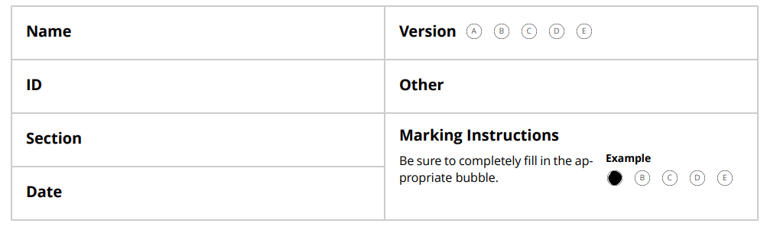
Fill in the appropriate ‘bubble’ on the answer sheet (as shown in the marking instructions example on the answer sheet).
If you change your mind after completing an answer, then put a cross through the incorrect bubble.
